**23.1.1**

You visit to New York. It’s soon

Yes. It is.

Do you know You want to do when you are here?

We want to have fun and see you.

Yes, without anything we can do. **Do you want to go camping?**

No, **I don’t want to come to NY city to go camping**.

OK, No camping. We can’t have a beach holiday because the cost

That’s OK. We are going to Bali for a beach holiday before we return to China

That’s nice

There was a great packet to deal

It include flights, hotel and car rentals

What kind of hotel is it?

It’s a beautiful 5 stars resorts

Can I go with you?

To Bali? No

Oh, OK. So what do you want to do when you walk in NY?

**We want to take a tour of the city**

**I want to do some sightseeing**

OK. **We can go sightseeing**, there are many thing to see here

Great! We have to go now. Take care!

Bye Shen

Talk to you soon!

Shen’s parents want to **have fun with Shen**

Shen’s parents do not want to **go camping**

Shen’s parents are happy about their trip to Bali because **it was a good deal**

What does Shen think about his parents’ beach holiday?

-> He wants to go with them

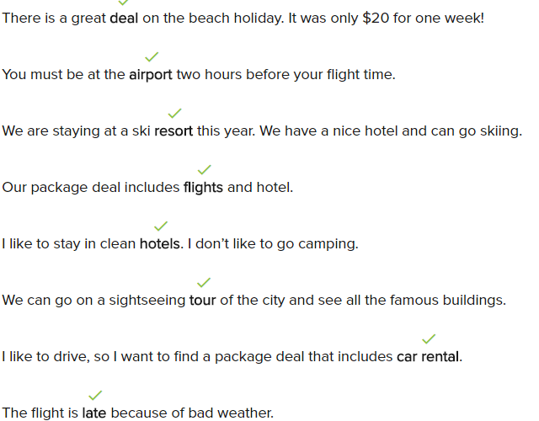

**Conversation**

There is a great deal on the beach holiday

Oh really? Does it include your flight and hotel?

Yes, we get a car too

It includes car rental, too? What’s the hotel like?

It stay very nice and big hotel with they pool of the meal are include it

Woa, you’re staying at a f starts resorts!

Yes, the hotel is on the beach, but it close to the city

Do they have sightseeing in tour?

Yes, we want to go all of city tour. What time do we need to be at the airport?

You need to be at the airport two hours before your fight

**Exercise**

I love trees, plants, and animals, so I like ti **go camping**

A **packet deal** includes fights, hotels, and car rentals

Let’s go on a **sightseeing tour** to see interesting things in the city

When we don’t work on Monday, we often take a **long weekend trip** in another city

There is freezing weather and snow. The fights are **late**

We don’t need to borrow your car because our packet includes **car rental**

I don’t go in holiday, but I travel quite a lot on business **trips**

I want to go somewhere warm

-> Let’s **go on beach holiday**

**23.1.2**

Shen! You’ve got mail!

I don’t have any email, I will on my computer

No real mail

What is it?

Open and see!

It’s my paycheck from Madi

Succeeding! It’s nice to get pay for the acting job

It’s a nice but they’re not acing job

What do you talking about? They’re not acting job?

**They were all regulars job**

They were all a regulars job? **So none of them were acting job?**

No, none of them were acting job

Woa, so you aren’t a door man or teacher in a movie or TV show

No

I’m sorry. It’s good Madi bring you in acting class, **all of those lesson can help you when you get a real acting job**

**Most of the classes don’t help me**

They don’t? why not?

None of student do the homework, so all of the screen we beform are bad

**Most of the actress I know aren’t serious about acting**. You are, the most to of all

You are right! A most student don’t like me because the teacher tell them, that I’m good and there are bad

She tell all of student are bad

Yes

But she like you. That’s good

Yeah

How do your feel today your fist paycheck?

I feel good

And I feel good because you feel good

You want to borrow money?

Just a little! Look at me, I don’t have money. I feel sad

Then you feel sad a lot

Why is Shen confused by Benny’s news?

-> Because he doen’t have any new emaila

What good news is in Shen’s mail?

-> He has some money

What problem does Shen have with the classes?

-> The students are not serious about the class

What does the teacher think about Shen?

-> The teacher thinks he is the best in the class

I did all of my homework, so I can meet my friends

Most of my friends like to go camping

The sightseeing tour goes to most of the interesting places in the city

I email all of my friends every weekend

None of the mail is for Benny

Why does Benny feel sorry for Shen?

-> None of Shen’s jobs were acting jobs

Shen feels good when he gets his first paycheck

Why does Shen feel bad about his acting class?

-> None of the students do their homework

When does Benny feel good?

-> When Shen feels good

When does Benny feel sad?

-> When he doesn’t have money

**Conversation**

How do you feel when you eat at the nice restaurant?

I feel happy when I go to a nice restaurant

Let’s go to at nice and expensive restaurant for dinner

I’m sorry, but I don’t have a lot of money

Oh, OK, how about a cheap fast food restaurant?

I don’t feel good after I eat cheap fast food

Let’s just order some pizza them

That sound nice! I want some of that pizza the peppers

Let’s order 3 large pizzas

Three larger pizzas? Can we eat all of the pizzas?

We don’t have to eat all of the pizza today, we can have some for breakfast

I like eating cold pizza in the morning

**Exercise**

I use **most of** my free time to go camping and look at the trees and animals

We can go on a beach holiday to a five-star resort. What do you think?

-> I think **that’s great!**

**I feel confused** because I can’t get a job. I always work hard!

I feel sad because **none** of my friends were at my dinner

The flight has problems, so none of the tourists on the plane can get there early

Do we need everything on the table to make the soup?

-> Yes, we need to use all of the ingredients on the table

**None of** us can speak Spanish, so it was difficult ordering in the Mexican restaurant

The food **was nice**, so I want to go back there